Inferring the MoA of drugs based on barcode fingerprints
Bastien CHASSAGNOL and Vera PANCALDI and Luca GRUMULATO and Marie-Pier SCOTT KELLY
2025-05-06
Contents

Welcome
This is the online Quarto book project for reproducing: Inferring the mechanism of action of new drugs through the analysis of the predetermined heterogeneous response to treatment of different subpopulations of cancer cells poster, presented at NetBioMed 2022 conference.

Introduction: Cell lines DNA Barcoding
- DNA barcoding is also used for inferring the species abundancies in environement samples, just replace the notion of species by cell lines. Similar statistical issues, with zero-inflated distributions.
- Steps:
  - Transfection by virus.
  - Clonal amplification, unique tagging per cell using MOI.
  - Clone sizes are assumed to be proportional to the barcode abundances due to this 1-1 mapping of a barcode and a single cell.
- Pros DNA barcoding:
  - Better capture of cell population sizes
  - Better tracking of tagged clones.
- Cons DNA barcoding:
  - Lack of systematic reviews and benchmarks.
  - Mostly rely on bulk RNASeq analytical tools, not accounting for drop-outs. In particular, the assumptions that variance across tags is homogeneous, and abundancies follow a negative binomial distribution are quite controversial.

1. Data management: metadata correction and cleansing

1.1 Reproducibility
I list below the R packages required to reproduce the analyses.
## data wrangling
library(dplyr)
library(tidyr)
library(stringr)
library(readr)
library(readxl)
library(purrr)
## reporting
library(flextable)
## plotting
library(ggplot2)
library(ComplexHeatmap)
library(cowplot)
library(grid)
library(RColorBrewer)
library(igraph)
## auxiliary functions
source("R/utils.R")
today_date <- "2025-04-28"
## today_date <- format(Sys.Date(), "%Y-%m-%d")
## set the seed, for fixing generation of ComplexHeatmaps (dendogram clustering)
set.seed(20)
- Original Google Drive repository.

1.2 Barcode counts cleaning
We early discarded exp130921_in vivo.csv from the experiences
Listing 1.1: Update labelling of latest experience.
exp271221 <- readr::read_csv("data/barcode-counts/exp271221.csv")
exp271221_whole <- readr::read_csv2("old-data-backup/data-raw/barcode-counts/exp211221cor.csv") |>
rename(barcode_id = 1)
selected_dataset <- compare_dataframes(exp271221, exp271221_whole)
file.rename("data/barcode-counts/exp211221.csv", "data/barcode-counts/exp271221.csv")

Code snippets in Listing 1.2 and Listing 1.3 aim at replacing unprecise labelling of barcode IDs (no concentration, no time duration, …) in the 2022 batch experiences.
Listing 1.2: Update labelling of latest experience.
## extract old colnames
exp281022_expression <- readr::read_csv("data/barcode-counts/exp281022.csv")
## cat(colnames(exp281022_expression), file = "281022_old_labels.txt", sep = "\n")
## extract mapping old_names with new_names
mapping_old_new_281022 <- readxl::read_excel("data/Table of compounds_whole_2025-04-28.xlsx",
sheet = "Sample Mapping 281022")
labels_old_new_281022 <- setNames(object = mapping_old_new_281022$OLD_replicate_label,
nm = mapping_old_new_281022$NEW_replicate_label)
## apply change labelling
exp281022_expression <- exp281022_expression |>
dplyr::rename(dplyr::all_of(labels_old_new_281022))
readr::write_csv(exp281022_expression, "data/barcode-counts/exp281022.csv")
Listing 1.3: Update time course experiences.
exp281022_expression_timecourse <- readr::read_csv("data/barcode-counts/exp281022_time course.csv")
## cat(colnames(exp281022_expression_timecourse), file = "281022_timecourse_old_labels.txt", sep = "\n")
## update colnames ----
mapping_old_new_time_course <- read_excel("data/Table of compounds_whole_2025-04-28.xlsx",
sheet = "Sample Mapping Time Course")
labels_old_new_time_course <- setNames(object = mapping_old_new_time_course$OLD_replicate_label,
nm = mapping_old_new_time_course$NEW_replicate_label)
## apply change labelling
exp281022_expression_timecourse <- exp281022_expression_timecourse |>
dplyr::rename(dplyr::all_of(labels_old_new_time_course))
readr::write_csv(exp281022_expression_timecourse,
"data/barcode-counts/exp281022_time course.csv")
## To evaluate whether controls are different between experiment 281022 and 281022 Time Course
controls_exp281022 <- exp281022_expression |>
select(key_barcode, dplyr::matches("^ctl")) |>
dplyr::inner_join(exp281022_expression_timecourse |>
select(key_barcode, dplyr::matches("^Ctrl")),
by="key_barcode")
cor(controls_exp281022$ctl2, controls_exp281022$Ctrl2) ## they strongly correlate with each other, but not a perfect match -> controls are indeed distinct

1.2.1 TODO: barcode counts inconsistencies
Things to consider:

- Some barcode counts exhibit final line index, for which reason?

1.2.2 Overview of barcode counts
We report in Table 1.1 a summary of the barcode counts (File location, batch_id, and dimensions of the counts matrix) considered for the generation of the Heatmaps, and the construction of a drug-drug network.
## 1) summarise kept batches ----
barcode_files <- list.files("./data/barcode-counts/",
pattern = "exp.*\\.csv",
full.names = TRUE)
kept_barcode_summaries <- purrr::map(barcode_files, function(filename) {
barcode_counts <- readr::read_csv(filename, show_col_types = FALSE)
experience_name <- filename |> basename() |> tools::file_path_sans_ext()
experience_summary <- tibble::tibble(`Experience Name`= experience_name,
Features= paste0("Barcode matrix contains: ",
nrow(barcode_counts),
" unique barcode IDs, and ",
ncol(barcode_counts)-1, " replicates."))
return(experience_summary)
}) |>
purrr::list_rbind()
flextable::flextable(kept_barcode_summaries) |>
bold(part="header")
## 2) summarise discarded batches ----
discarded_files <- list.files("./data/barcode-counts/temp discarded/",
pattern = "exp.*\\.csv",
full.names = TRUE)
## change format + barcode name
barcode_discarded_summaries <- purrr::map(discarded_files, function(filename) {
barcode_counts <- readr::read_csv(filename, show_col_types = FALSE)
experience_name <- filename |> basename() |> tools::file_path_sans_ext()
experience_summary <- tibble::tibble(`Experience Name`= experience_name,
Features= paste0("Barcode matrix contains: ",
nrow(barcode_counts),
" unique barcode IDs, and ",
ncol(barcode_counts)-1, " replicates."))
return(experience_summary)
}) |>
purrr::list_rbind()
flextable::flextable(barcode_discarded_summaries) |>
bold(part="header")
Experience Name | Features
exp010821 | Barcode matrix contains: 869714 unique barcode IDs, and 16 replicates.
exp040821 | Barcode matrix contains: 869714 unique barcode IDs, and 16 replicates.
exp070222 | Barcode matrix contains: 93132 unique barcode IDs, and 68 replicates.
exp130921 | Barcode matrix contains: 627539 unique barcode IDs, and 24 replicates.
exp151121 | Barcode matrix contains: 844434 unique barcode IDs, and 60 replicates.
exp181021 | Barcode matrix contains: 813579 unique barcode IDs, and 59 replicates.
exp200921 | Barcode matrix contains: 627539 unique barcode IDs, and 40 replicates.
exp200921_dose response osim | Barcode matrix contains: 1067031 unique barcode IDs, and 20 replicates.
exp220322 | Barcode matrix contains: 93132 unique barcode IDs, and 66 replicates.
exp271221 | Barcode matrix contains: 844434 unique barcode IDs, and 80 replicates.
exp281022 | Barcode matrix contains: 315642 unique barcode IDs, and 22 replicates.
exp281022_time course | Barcode matrix contains: 398004 unique barcode IDs, and 51 replicates.
exp300821 | Barcode matrix contains: 413335 unique barcode IDs, and 28 replicates.
(a) Kept Batches

Experience Name | Features
exp130921_in vivo | Barcode matrix contains: 813579 unique barcode IDs, and 16 replicates.
exp200921_dose response osim | Barcode matrix contains: 813579 unique barcode IDs, and 20 replicates.
(b) Removed batches

Table 1.1: Overview of the Barcoding Batches.
From Table 1.1, 13 barcode experiences are included in the analysis, whereas 2 batches/experiences are filtered out.

1.3 Phenotype metadata cleaning

Most of the R instructions reported in this section aim at rendering the Table of compounds file compliant with the tidy format, see Tip 1.1. These data-wrangling operations are split in 4 steps:
- In Listing 1.4, we homogenise Concentrations, Date and Duration to ISO standards, while dealing with erroneous missing values generated by fused Excel cells.
- In Listing 1.5, we retrieve from each individual barcode counts profile, the individual replicates ID identifying unequivocally each replicate. We set apart replicates that could be mapped back to original Table of compounds file.
- In Listing 1.6, we merge together in a comprehensive phenotype table the short Samples_ID (short term referring to drugs listed in Compound column), the full Compound (complete name of drugs) and map each of them to its complete list of replicates (from 2 to 8). We save the output in data-derived.
- Finally, in Listing 1.7 and Listing 1.8, we perform several posterior data integrity checks to verify if i) we were able to map each individual replicate ID to its original ID in Table of compounds, and ii) if the number of replicates reported in Table of compounds was consistent with the number of barcode profiles.
Listing 1.4: Coerce original Excel file reporting experimental design to tidy format.
pheno_colnames <- c(Pathway = "Pathways", MoA = "...2",
Compound = "Samples", Replicates = "Replicates",
Concentrations = "Concentrations", Date = "Experiment date",
`Run date` = "Run date", Duration="Duration",
Kept="Kept", Comments = "Comments")
## prune irrelevant colnames ----
## data/Table of compounds_stringent_2025-04-18.xlsx
pheno_data <- readxl::read_xlsx("data/Table of compounds_whole_2025-04-28.xlsx",
sheet = "Experimental Design",
col_types = c(rep("text", 3), "numeric",
rep("text", 4), "logical", "text")) |>
dplyr::rename(dplyr::all_of(pheno_colnames)) |>
tidyr::fill(Pathway, MoA, .direction = "down")
pheno_data_discarded <- pheno_data |>
dplyr::filter(!Kept)
## Add batches and correct for fused Excel cells ----
pheno_data <- pheno_data |>
## extract last 6 numbers
dplyr::mutate(Compound = if_else(grepl("Control", MoA, ignore.case = TRUE),
MoA, Compound),
`Run date` = stringr::str_sub(`Run date`, -6, -1),
Batch_ID= paste0("exp", Date)) |>
tidyr::fill(Compound, .direction = "down") |>
## remove unwanted replicates
dplyr::filter(Kept) |>
dplyr::mutate(Batch_ID = dplyr::if_else(Comments %in% c("Dose Response"),
"exp200921_dose response osim", Batch_ID)) |>
dplyr::mutate(Batch_ID = dplyr::if_else(Comments %in% c("Time Course"),
"exp281022_time course", Batch_ID),
Pathway = if_else(is.na(Pathway), MoA, enc_to_ascii(Pathway))) |>
dplyr::select(- Comments, -Kept) |>
dplyr::distinct(.keep_all = TRUE) ## remove duplicates
## format concentrations, creating both 'Concentrations_ID' and 'Concentrations' in Moles ----
pheno_data <- pheno_data |>
dplyr::mutate(Concentrations=if_else(Compound=="Control", "000 uM", Concentrations)) |>
dplyr::mutate(Concentrations=if_else(Compound=="Osimertinb+sorafenib", "015 uM", Concentrations)) |>
tidyr::separate_wider_delim(Concentrations, delim = " ", names = c("Concentrations Value", "Unit"), cols_remove = FALSE) |>
dplyr::rename(OLD_Concentrations=Concentrations) |>
dplyr::mutate(Unit = case_when(
Unit %in% c("uM", "µM", "µg/ml") ~ "u",
Unit == "nM" ~ "n",
Unit %in% c("mg/kg", "mM") ~ "m",
)) |>
dplyr::mutate(Concentrations=parse_number(`Concentrations Value`, trim_ws = TRUE,
locale = locale(decimal_mark = ",", grouping_mark = "."))) |>
dplyr::mutate(Concentrations = case_when(
Unit == "u" ~ Concentrations *10^-6,
Unit == "n" ~ Concentrations *10^-9,
Unit == "m" ~ Concentrations *10^-3)) |>
dplyr::mutate(`Concentrations Value`=parse_number(`Concentrations Value`, trim_ws = TRUE,
locale = locale(decimal_mark = ",", grouping_mark = ".")) |>
format_concentrations()) |>
tidyr::unite(col ="Concentrations_ID", `Concentrations Value`, Unit, sep = "")
## format Durations, creating both 'Duration_ID' and 'Duration' as an integer value in Days ----
pheno_data <- pheno_data |>
## extract last 6 numbers, as the only ones used for identification of samples downstream
dplyr::mutate(Duration_ID = Duration,
Duration = parse_number(Duration, trim_ws = TRUE,
locale = locale(decimal_mark = ".")),
Duration = dplyr::if_else(grepl("m$", Duration_ID),
Duration*30, Duration))
 Metadata inconsistencies and Conversion to UIC Units
In Listing 1.5 and Listing 1.6, we identify which raw barcode counts matrices avalaible in folder barcode-counts are not reported in the global experimental dataset, and reciprocally. Finally, we only keep experiences that are both reported in Table of compounds and present in barcode-counts folder..
Listing 1.5: Identify shared experience IDs between experimental design table (Table of compounds), and barcode-count counts profiles.
## keep only relevant files
barcodes_filenames <- list.files("./data/barcode-counts/",
pattern = "^exp.*\\.csv$")
barcodes_IDs <- readxl::read_xlsx("data/Table of compounds_whole_2025-04-28.xlsx",
sheet="Batch Mapping") |>
select(Filename, Batch_ID) |>
filter(!Batch_ID %in% c("exp130921_in vivo")) |>
mutate(Filename =paste0(Filename, ".csv"),
Date = stringr::str_extract(Batch_ID, "(?<=^exp)[[:digit:]]{6}"))
To generate the final phenotype dataset, we only keep experiences that were reported both in Table of Compound and folder barcode-counts in Listing 1.6.
Listing 1.6: Map each compound to its full list of replicates. Generate a Batch_ID to unequivocally ientify each run of experiences, and convert all run Dates to their international format.
## step 1) keep only shared Batch_ID experiences ----
barcodes_IDs <- barcodes_IDs |>
dplyr::semi_join(pheno_data, by="Batch_ID")
## exp201021 is discarded, that's normal, we just want to keep the controls!!
pheno_data <- pheno_data |>
dplyr::semi_join(barcodes_IDs, by="Batch_ID")
## step 2) extract individual replicate IDs directly from sample experiences ----
## Filename <- "exp281022.csv"; Batch_ID <- "exp281022"; Date <- "281022"
ID_mapping <- purrr::pmap(barcodes_IDs, function(Filename, Batch_ID, Date) {
## build path
counts_path <- file.path("data","barcode-counts",
paste0(Filename))
## extract replicate names (reading the header)
replicates_ID <- strsplit(readLines(counts_path, n = 1), split = ",")[[1]] |>
str_subset("\\S") |> ## remove empty strings and 'key'
str_subset("barcode_id", negate = TRUE)
## ID: combination of letters, numbers and -, followed by '[1-4]_', starting the sample's name
dataset_ID <- tibble::tibble(Batch_ID = Batch_ID,
Date = stringr::str_extract(replicates_ID,
"(?<=_exp)[[:alnum:]]{6}"),
Replicates_ID = replicates_ID,
`Run date` = stringr::str_extract(replicates_ID,
"(?<=_run)[[:alnum:]]{6}(?=_)"),
Concentrations_ID = stringr::str_extract(replicates_ID,
"(?<=[1-8]_)[[:digit:]]{3}[gmnux]{1}(?=_exp)")) |>
## account for second notation syntax for concentrations
dplyr::mutate(Concentrations_ID = if_else(is.na(Concentrations_ID),
stringr::str_extract(replicates_ID,
"(?<=[1-8]_)[0-9]{1}\\.[0-9]{2}[gmnux]{1}(?=_exp)"),
Concentrations_ID))
## Deal with two time notations
if (grepl("Time",Batch_ID, ignore.case = TRUE)) {
dataset_ID <- dataset_ID |>
dplyr::mutate (Samples_ID = stringr::str_extract(replicates_ID,
"(?<=_)[[[:alnum:]]\\-]+(?=[1-8]_)"),
Duration_ID=stringr::str_extract(replicates_ID,
"^[[[:alnum:]]\\.]{1,3}[dm](?=_)"))
}
else {
dataset_ID <- dataset_ID |>
dplyr::mutate (Samples_ID = stringr::str_extract(replicates_ID,
"^[[[:alnum:]]\\-]+(?=[1-8]{1}_)"),
Duration_ID="9d")
}
return(dataset_ID)
}) |>
purrr::list_rbind()
## deal with specific p42 and p43
ID_mapping <- ID_mapping |>
dplyr::mutate(Samples_ID = if_else(grepl("^p42", Replicates_ID), "p42", Samples_ID),
Samples_ID = if_else(grepl("^p43", Replicates_ID), "p43", Samples_ID))
## remove irrelavant samples
ID_mapping <- ID_mapping |>
dplyr::filter(!grepl("^p42|^p43|^CTRL", Replicates_ID))
## detect miscatech samples
## ID_mapping_missing <- ID_mapping |>
## filter(if_any(everything(), is.na))
## step 3) map short compound IDs with full compound names ----
mapping_compounds <- readxl::read_xlsx("data/Table of compounds_whole_2025-04-28.xlsx",
sheet = "Drugs Mapping")
ID_mapping <- ID_mapping |>
inner_join(mapping_compounds, by = "Samples_ID")
## test <- ID_mapping |> anti_join(mapping_compounds, by = "Samples_ID")
## test2 <- mapping_compounds |> anti_join(ID_mapping, by = "Samples_ID")
Finally, in Listing 1.7, we map all replicates (one column in a given barcode count matrix) to its comprehensive metadata descripion (stored in Tables of compounds), using as primary and foreign keys the following 6 variables: Batch_ID, Compound, Duration_ID, Run date, Date, and Concentrations_ID.
Listing 1.7: Extract discarded replicates
replicates_discarded <- dplyr::anti_join(ID_mapping, pheno_data,
by = c("Batch_ID", "Compound", "Duration_ID",
"Run date", "Date", "Concentrations_ID"))
pheno_data_unmapped <- dplyr::anti_join(pheno_data,
ID_mapping,
by = c("Batch_ID", "Compound", "Duration_ID",
"Run date", "Date", "Concentrations_ID"))
pheno_data_unmapped |>
arrange(Compound, Date, Concentrations_ID) |>
flextable() |>
bold(part = "header")

Pathway | MoA | Compound | Replicates | Concentrations_ID | OLD_Concentrations | Date | Run date | Duration | Batch_ID | Concentrations | Duration_ID
Table 1.2: Identify set of experiences reported in Table of compounds that could not be mapped against their corresponding Barcode counts replicates. We check this information with an anti_join between original phenotype and counts, returning samples from Table of Compound that could not have been mapped back.
In Table 1.3, we check discrepancies between the number of barcode replicates reported in Table of compounds with the number of replicates avalaible in barcode counts matrices.
Listing 1.8: Secound round of data wrangling quality controls on counts versus phenotype data, focusing on divergent number of replicates.
replicate_inconsistencies <- pheno_data |>
dplyr::inner_join(ID_mapping,
by = c("Batch_ID", "Date",
"Compound", "Run date",
"Concentrations_ID", "Duration_ID")) |>
group_by(Batch_ID, Compound, Date, Replicates, Concentrations_ID,Duration_ID) |>
summarise(n=n()) |>
filter(n!=Replicates)
flextable(replicate_inconsistencies) |>
autofit() |>
bold(part = "header")

Batch_ID | Compound | Date | Replicates | Concentrations_ID | Duration_ID | n
exp220322 | XAV-939 | 220322 | 4 | 080u | 9d | 2
Table 1.3: Secound round of data wrangling quality controls on counts versus phenotype data, focusing on divergent number of replicates.

1.3.1 Save phenotype Metadata
By applying all the formatting analyses reported in Section 1.3, we generate in Table 1.4 a global metadata phenotypic table, adhering to tidy principles Tip 1.1.
 Tip 1.1: Tidy Data Format (Key Principles)
- Each variable has its own column.
- Each observation has its own row – Every row corresponds to one observation.
- Each value has its own cell – Each cell contains a single, unique value.
This format streamlines data wrangling, and generally speaking, data analysis and visualisation. In other words, prefer simpler CSV formats for the experimental design, and avoid cell fusion in Excel documents. Finally, for the formatted tabular representation in documentations, I use flextable.
Listing 1.9: Save the final metadata annotations for barcodes, using Today’s date for historical versioning.
## step 4) Use international date formats ----
pheno_data_formatted <- pheno_data |>
dplyr::inner_join(ID_mapping,
by = c("Batch_ID", "Date",
"Compound", "Run date",
"Concentrations_ID", "Duration_ID")) |>
dplyr::select(Batch_ID, Pathway, MoA,
Compound, Samples_ID,
Replicates, Replicates_ID,
Concentrations, Concentrations_ID,
Date, `Run date`, Duration, Duration_ID) |>
## convert to ISO 1860 Date format
mutate(Date = lubridate::dmy(Date) |> format(),
`Run date`= lubridate::dmy(`Run date`),
## artifically de-duplicate controls for exp, simplify the analytical workflow
Replicates_ID = dplyr::if_else(Batch_ID %in% c("exp200921_dose response osim") &
Compound=="Control",
gsub("exp200921_", "exp200921_dose_response_", Replicates_ID),
Replicates_ID))
## 2) QC: guarantee uniqueness of the replicates
pheno_data_deduplicated <- pheno_data_formatted |>
dplyr::distinct(Replicates_ID, .keep_all = TRUE)
all.equal(pheno_data_deduplicated, pheno_data_formatted)
## [1] TRUE
## 3) save as .xlsx file discarded and preserved replicates
barcode_counts_summaries <- list("kept counts" = kept_barcode_summaries,
"kept compounds" = pheno_data,
"kept replicates" = pheno_data_formatted |>
select(Compound, Replicates_ID),
"discarded counts" = barcode_discarded_summaries,
"discarded compounds"=pheno_data_discarded,
"discarded replicates" = replicates_discarded)
openxlsx::write.xlsx(x = barcode_counts_summaries,
file = paste0("./data/logs/barcode_metadata_overview_",
today_date,".xlsx"),
overwrite = TRUE, asTable = TRUE)
## 4) save the tidy phenotype metatada table ----
readr::write_csv(pheno_data_formatted,
file = paste0("data/pheno_data_metadata_", today_date,".csv"))
flextable::flextable(head(pheno_data_formatted)) |>
autofit() |>
bold(part="header")

Batch_ID | Pathway | MoA | Compound | Samples_ID | Replicates | Replicates_ID | Concentrations | Concentrations_ID | Date | Run date | Duration | Duration_ID
exp010821 | Control | Control | Control | Contro | 4 | Contro1_000u_exp010821_run180821_03 | 0 | 000u | 2021-08-01 | 2021-08-18 | 9 | 9d
exp010821 | Control | Control | Control | Contro | 4 | Contro2_000u_exp010821_run180821_04 | 0 | 000u | 2021-08-01 | 2021-08-18 | 9 | 9d
exp010821 | Control | Control | Control | Contro | 4 | Contro3_000u_exp010821_run180821_05 | 0 | 000u | 2021-08-01 | 2021-08-18 | 9 | 9d
exp010821 | Control | Control | Control | Contro | 4 | Contro4_000u_exp010821_run180821_06 | 0 | 000u | 2021-08-01 | 2021-08-18 | 9 | 9d
exp040821 | Control | Control | Control | Contro | 4 | Contro1_000u_exp040821_run180821_25 | 0 | 000u | 2021-08-04 | 2021-08-18 | 9 | 9d
exp040821 | Control | Control | Control | Contro | 4 | Contro2_000u_exp040821_run180821_26 | 0 | 000u | 2021-08-04 | 2021-08-18 | 9 | 9d
Table 1.4
Conclusion: on a total of 544, 532 replicates are kept, and 12 replicates were removed.

2. Methods: normalise, identify DRBs and save as SummarizedExperiment objects

2.1 Reproducibility
I list below the R packages required to reproduce the analyses.
## data wrangling
library(dplyr)
library(tidyr)
library(stringr)
library(readr)
library(readxl)
library(openxlsx)
library(purrr)
## reporting
library(flextable)
# automated package linting
library(xml2)
library(downlit)
## auxiliary functions
source("R/utils.R")
today_date <- "2025-04-28"
## today_date <- format(Sys.Date(), "%Y-%m-%d")
## set the seed, for fixing generation of ComplexHeatmaps (dendogram clustering)
set.seed(20)

2.2 Preprocessing barcode counts
Code colour:
, and

2.2.1 Background Noise Removal and SummarizedExperiment stantardised storage

Listing 2.1: Remove background noise.
barcode_files <- list.files("./data/barcode-counts/",
pattern = "exp.*\\.csv",
full.names = TRUE)
thresh_background <- 4
## ./data/pheno_data_metadata_2025-04-18.csv
pheno_data <- readr::read_csv(paste0("./data/pheno_data_metadata_",
today_date, ".csv"))
## filename <- grep( "exp200921", barcode_files, value = TRUE)[2]
barcode_counts_aggregated <- purrr::map(barcode_files, function(filename) {
barcode_counts <- readr::read_csv(filename)
experience_name <- filename |> basename() |> tools::file_path_sans_ext()
## 1) explicitly change replicates name to enable 1-1 mapping ----
if (experience_name=="exp200921_dose response osim") {
barcode_counts <- barcode_counts |>
dplyr::rename_with(
.fn = ~ gsub("exp200921_", "exp200921_dose_response_", .x),
.cols = starts_with("Contro"))
}
replicates_names <- setdiff(colnames(barcode_counts), "barcode_id")
## 2) Remove lowly expressed barcodes ----
control_index <- pheno_data |>
dplyr::filter(Batch_ID==experience_name &
Compound=="Control" &
Replicates_ID %in% replicates_names) |>
dplyr::pull(Replicates_ID)
signicant_barcodes_index <- which(rowSums(barcode_counts[, control_index]) > thresh_background)
filtered_barcode_counts <- barcode_counts[signicant_barcodes_index,]
message(paste("\n\nWe are considering experiment:", experience_name, "with", nrow(filtered_barcode_counts), "barcode IDs kept.\n\n"))
return(filtered_barcode_counts)
}) |>
purrr::reduce(~ inner_join(.x, .y, by = "barcode_id"))
## Deal with specific duplicated colnames, resulting from control duplicates
## barcode_counts_aggregated <- barcode_counts_aggregated |>
## dplyr::select(!ends_with(".y")) |>
## dplyr::rename_with(.fn = ~ gsub("\\.x$", "", .x),
## .cols = dplyr::ends_with(".x"))
## 3) keep only replicates present in pheno_data
barcode_counts_aggregated <- barcode_counts_aggregated |>
select(all_of(c("barcode_id", pheno_data$Replicates_ID)))
- After filtering for background noise, and merging all experiences based on shared barcode IDs, 4629 unique barcode IDs are kept, for 532 samples, see Listing 2.1 for details.

2.2.2 Normalisation
- . This operation is performed in Listing 2.2.
Listing 2.2: Normalise by $100000$.
## 1) normalise by total number of counts ----
barcode_counts_normalised <- barcode_counts_aggregated |>
mutate(across(
.cols = where(is.numeric),
.fns = ~ (.x / sum(.x)) * 1e5))

2.2.3 Prepare SummarizedExperiment objects for normalised data
- Higher level of granularity in Listing 2.3:
Listing 2.3: Simply compute the Pearson correlation score at the replicate level, and save the output as a SummarizedExperiment.
## 2) prepare SummarizedExperiment inputs ----
## Barcode counts at replicate level
barcode_normalised_replicates_mat <- barcode_counts_normalised |>
tibble::column_to_rownames("barcode_id") |>
as.matrix()
## Sample metadata
pheno_data_replicates <- pheno_data |>
tibble::column_to_rownames("Replicates_ID")
## Feature metadata
barcode_metadata <- tibble::tibble(barcode_id = barcode_counts_normalised$barcode_id)
row.names(barcode_metadata) <- barcode_metadata$barcode_id
## 3) Buid and Save SummarizedExperiment
se_replicates <- SummarizedExperiment::SummarizedExperiment(
assays = list(counts = barcode_normalised_replicates_mat),
rowData = barcode_metadata,
colData = pheno_data_replicates)
- Medium level of granularity in Listing 2.4, averaging over replicates:
Listing 2.4: Simply compute the Pearson correlation score at the Compound per Batch level.
barcode_counts_long <- barcode_counts_normalised |>
tidyr::pivot_longer(-barcode_id,
names_to = "Replicates_ID",
values_to = "Barcode_Counts") |>
dplyr::inner_join(pheno_data, by="Replicates_ID")
barcode_counts_wider_compound_batch <- barcode_counts_long |>
tidyr::pivot_wider(id_cols = c(barcode_id),
names_from = c(Batch_ID, Compound, Concentrations_ID, Duration_ID),
names_sep = ":",
values_from = Barcode_Counts,
values_fn=mean)
pheno_compound_batch <- tibble::tibble(original =setdiff(colnames(barcode_counts_wider_compound_batch),"barcode_id")) |>
mutate(Batch_ID = stringr::str_split_i(original, ":", 1),
Compound = stringr::str_split_i(original, ":", 2),
Concentrations_ID = stringr::str_split_i(original, ":", 3),
Duration_ID = stringr::str_split_i(original, ":", 4)) |>
inner_join(pheno_data |> select(Batch_ID, Pathway, MoA, Compound,
Concentrations, Concentrations_ID, Duration, Duration_ID),
by = c("Batch_ID", "Compound", "Concentrations_ID", "Duration_ID")) |>
dplyr::distinct() |>
dplyr::select(-Concentrations_ID, -Duration_ID) |>
tibble::column_to_rownames("original")
se_compound_batch <- SummarizedExperiment::SummarizedExperiment(
assays = list(counts = barcode_counts_wider_compound_batch |>
tibble::column_to_rownames("barcode_id") |>
as.matrix()),
rowData = barcode_metadata,
colData = pheno_compound_batch)
- Low level of granularity in Listing 2.5, with one CC per compound:
Listing 2.5: Compute the Pearson correlation score, after averaging the barcode counts per compound.
barcode_counts_wider_by_compound <- barcode_counts_long |>
tidyr::pivot_wider(id_cols = c(barcode_id),
names_from = c(Compound),
values_from = Barcode_Counts,
values_fn=mean)
pheno_compound <- tibble::tibble(Compound = setdiff(colnames(barcode_counts_wider_by_compound), "barcode_id")) |>
inner_join(pheno_data |> select(Pathway, MoA, Compound),
by = c("Compound")) |>
dplyr::distinct() |>
tibble::column_to_rownames("Compound")
se_compound <- SummarizedExperiment::SummarizedExperiment(
assays = list(counts = barcode_counts_wider_by_compound |>
tibble::column_to_rownames("barcode_id") |>
as.matrix()),
rowData = barcode_metadata,
colData = pheno_compound)
saveRDS(se_replicates, file = paste0("./results/compounds/se_normalised_per_replicate_",
today_date, ".rds"))
saveRDS(se_compound_batch, file = paste0("./results/compounds/se_normalised_per_compound_by_batch_",
today_date, ".rds"))
saveRDS(se_compound, file = paste0("./results/compounds/se_normalised_per_compound_",
today_date, ".rds"))

2.3 Differential analyses and Binarisation

Listing 2.6: Compute the averaged value for control replicates, then binarise for each compound. A 1 denoting a significant positive enrichment for a given barcode_id.
## Step 1: Compute control means per barcode_id and Batch ----
threshold_FC <- 3
control_means <- barcode_counts_long |>
filter(Compound == "Control") |>
group_by(Batch_ID, barcode_id) |>
summarise(Control_Mean = mean(Barcode_Counts), .groups = "drop")
## Step 2: Join control mean to full dataset ----
barcode_discretised_replicates <- barcode_counts_long |>
left_join(control_means,
by = c("Batch_ID","barcode_id"))
## Step 3: Compute Fold Change and discretise ----
barcode_discretised_replicates <- barcode_discretised_replicates |>
filter(Compound != "Control") |>
mutate(Diff = Barcode_Counts - Control_Mean,
Barcode_Counts = if_else(Diff > threshold_FC, 1, 0)) |>
## Final cleanup
select(-Diff, -Control_Mean) |>
dplyr::mutate(Barcode_Counts = as.logical(Barcode_Counts))
.

2.3.1 SummarizedExperiment of binarised markers
- SummarizedExperiment at the replicates level (controls being discarded)
## Step 4: Save as a SummarizedExperiment ----
barcode_discretised_replicates_mat <- barcode_discretised_replicates |>
tidyr::pivot_wider(id_cols = barcode_id, names_from = Replicates_ID, values_from = Barcode_Counts)
pheno_replicates_discretised <- pheno_data |>
dplyr::filter(Replicates_ID %in% barcode_discretised_replicates$Replicates_ID) |>
tibble::column_to_rownames("Replicates_ID")
se_discretised_replicates <- SummarizedExperiment::SummarizedExperiment(
assays = list(binarised = barcode_discretised_replicates_mat |>
tibble::column_to_rownames("barcode_id") |>
as.matrix()),
rowData = barcode_metadata,
colData = pheno_replicates_discretised)
saveRDS(se_discretised_replicates,
file = paste0("./results/compounds/se_discretised_per_replicate_",
today_date, ".rds"))

Listing 2.7: Average the replicates, using a all operator.
## 2) discretised correlation at the compound by batch level (averaging over replicates), with an all function
barcode_discretised_compound_batch <- barcode_discretised_replicates |>
tidyr::pivot_wider(id_cols = c(barcode_id),
names_from = c(Batch_ID, Compound, Concentrations_ID, Duration_ID),
names_sep = ":",
values_from = Barcode_Counts,
values_fn=all)
pheno_discretised_compound_batch <- pheno_compound_batch[setdiff(colnames(barcode_discretised_compound_batch), "barcode_id"), ]
se_compound_batch_discretised <- SummarizedExperiment::SummarizedExperiment(
assays = list(discretised = barcode_discretised_compound_batch |>
tibble::column_to_rownames("barcode_id") |>
as.matrix()),
rowData = barcode_metadata,
colData = pheno_discretised_compound_batch)
saveRDS(se_compound_batch_discretised,
file = paste0("./results/compounds/se_discretised_per_compound_by_batch_",
today_date, ".rds"))

Listing 2.8: Aggregate at the compound level, assigning a 1 if barcode cell lines were found positiveliy enriched in all compounds.
## 2) discretised correlation at the compound by batch level (averaging over replicates), with an all function
barcode_discretised_compound <- barcode_discretised_replicates |>
tidyr::pivot_wider(id_cols = c(barcode_id),
names_from = c(Compound),
names_sep = ":",
values_from = Barcode_Counts,
values_fn=all)
pheno_discretised_compound<- pheno_compound[setdiff(colnames(barcode_discretised_compound), "barcode_id"), ]
se_compound_discretised <- SummarizedExperiment::SummarizedExperiment(
assays = list(discretised = barcode_discretised_compound |>
tibble::column_to_rownames("barcode_id") |>
as.matrix()),
rowData = barcode_metadata,
colData = pheno_discretised_compound)
saveRDS(se_compound_discretised,
file = paste0("./results/compounds/se_discretised_per_compound_",
today_date, ".rds"))

3. Results: Heatmaps and Drug networks, based on barcode fingerprints

3.1 Reproducibility
I list below the R packages required to reproduce the analyses.
## data wrangling
library(dplyr)
library(tidyr)
library(stringr)
library(purrr)
## plotting
library(ggplot2)
library(ComplexHeatmap)
library(cowplot)
library(grid)
library(RColorBrewer)
library(igraph)
library(magick)
## auxiliary functions
source("R/utils.R")
today_date <- "2025-04-28"
## today_date <- format(Sys.Date(), "%Y-%m-%d")
## set the seed, for fixing generation of ComplexHeatmaps (dendogram clustering)
set.seed(20)

3.2 Compute Compound Similarities

3.2.1 Compound Heatmaps
- Some tutorials:
  - Blend of useful resources on generating Heatmaps:
  - Mapping quantitative data to color, from Gehlenborg and Wong (2012):
  - Real-Life Examples with ComplexHeatmap:
    - Heatmap with transcriptomic expression
    - Heatmap with genomic expression
    - Genome-level Heatmap
    - Plotting large heatmaps in R and Rasterisation, with thousands of genes to be considered.
    - Control size of Heatmaps
  - Real-life examples with ggplot2
  - Real-Life examples with funkyheatmap CRAN package

3.2.1.1 Heatmap with Pearson correlation score
- Heatmap in Figure 3.1 is generated at the replicate level:
## Read SummarizedExperiment object
se_normalised_replicate <- readRDS(paste0("./results/compounds/se_normalised_per_replicate_", today_date, ".rds"))
se_normalised_replicate_mat <- SummarizedExperiment::assay(se_normalised_replicate)
se_normalised_pheno_data_replicate <- SummarizedExperiment::colData(se_normalised_replicate)
se_normalised_pheno_data_replicate$log10Conc <- if_else(se_normalised_pheno_data_replicate$Concentrations==0,
0,
-log10(se_normalised_pheno_data_replicate$Concentrations))
## Compute global correlation score
cor_per_replicate <- cor(se_normalised_replicate_mat)
## Define clustering colours
col_heatmap_scale <- circlize::colorRamp2(c(min(cor_per_replicate), 0, 1),
c("blue", "white", "red"))
## Define custom colour Heatmap annotation
## num_batches <- length(unique(se_normalised_pheno_data_replicate$Batch_ID))
## num_compounds <- length(unique(se_normalised_pheno_data_replicate$Compound))
## num_moa <- length(unique(se_normalised_pheno_data_replicate$MoA))
##
## batch_col <- setNames(colorRampPalette(brewer.pal(8, "Dark2"))(num_batches),
## unique(se_normalised_pheno_data_replicate$Batch_ID))
## compound_col <- setNames(colorRampPalette(brewer.pal(11, "Spectral"))(num_compounds),
## unique(se_normalised_pheno_data_replicate$Compound))
## moa_col <- setNames(colorRampPalette(brewer.pal(12, "Set3"))(num_moa),
## unique(se_normalised_pheno_data_replicate$MoA))
## Heatmap annotation
top_ha <- ComplexHeatmap::HeatmapAnnotation(df = se_normalised_pheno_data_replicate |>
as.data.frame() |>
dplyr::select(Batch_ID, MoA, Compound))
## col = list(Batch_ID = batch_col,
## MoA = moa_col,
## Compound = compound_col))
row_ha <- ComplexHeatmap::rowAnnotation(Concentration =
ComplexHeatmap::anno_barplot(se_normalised_pheno_data_replicate$log10Conc),
Duration = paste0(se_normalised_pheno_data_replicate$Duration, "d"))
## 1) Generate HeatMap
heatmap_normalised_replicates <- ComplexHeatmap::Heatmap(cor_per_replicate,
col=col_heatmap_scale,
name = "CC for all Replicates",
show_row_names = TRUE,
show_column_names = FALSE,
row_dend_reorder = TRUE,
column_dend_reorder = TRUE,
## font size
row_names_gp = gpar(fontsize = 2),
column_names_gp = gpar(fontsize = 2),
column_names_rot = 45,
top_annotation = top_ha,
right_annotation = row_ha,
## matrix size
width = ncol(cor_per_replicate)*unit(1, "mm"),
height = nrow(cor_per_replicate)*unit(1, "mm"))
size_heatmap <- calc_ht_size(heatmap_normalised_replicates)
padding_heatmap <- unit(c(2, 15, 2, 2), "mm")
## 2) Save png and pdf outputs
png(paste0("figures/compounds/heatmap_normalised_replicates_", today_date,".png"),
res = 200,
width = size_heatmap$width, height = size_heatmap$height, units = c("in"))
heatmap_normalised_replicates |> ComplexHeatmap::draw(padding = padding_heatmap)
dev.off()
## png
## 2
knitr::include_graphics(paste0("figures/compounds/heatmap_normalised_replicates_", today_date,".png"),
auto_pdf = TRUE,
dpi = 100)
ggsave(paste0("figures/compounds/heatmap_normalised_replicates_", today_date,".pdf"),
heatmap_normalised_replicates |>
ComplexHeatmap::draw(padding = padding_heatmap) |>
grid::grid.grabExpr(),
dpi = 100,
width = size_heatmap$width, height = size_heatmap$height, units = c("in"))
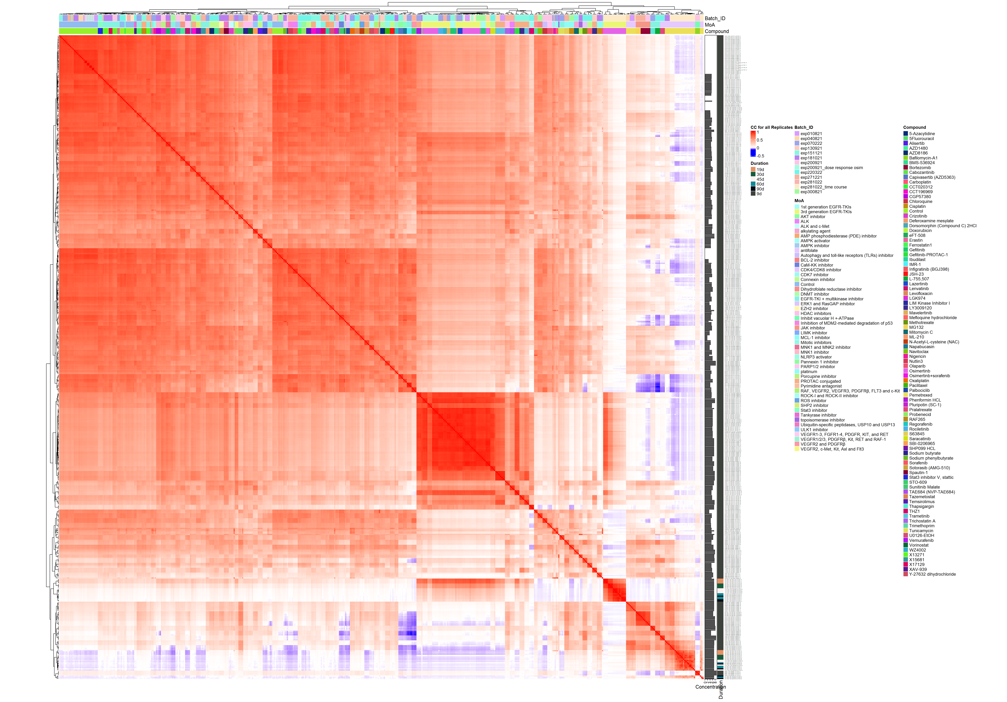
Figure 3.1: Heatmap of normalised replication scores, generated with the simple Pearson Correlation score.
- Heatmap in Figure 3.2 is generated by averaging normalised barcode counts over replicates:
## Read SummarizedExperiment object
se_normalised_compound_batch <- readRDS(paste0("./results/compounds/se_normalised_per_compound_by_batch_", today_date, ".rds"))
se_normalised_compound_batch_mat <- SummarizedExperiment::assay(se_normalised_compound_batch)
se_pheno_data_normalised_compound_batch <- SummarizedExperiment::colData(se_normalised_compound_batch)
## Compute global correlation score
cor_per_compound_by_batch <- cor(se_normalised_compound_batch_mat)
## Define clustering colours
col_heatmap_scale <- circlize::colorRamp2(c(min(cor_per_compound_by_batch), 0, 1),
c("blue", "white", "red"))
## Heatmap annotation
ha <- ComplexHeatmap::HeatmapAnnotation(df = se_pheno_data_normalised_compound_batch |>
as.data.frame() |>
dplyr::select(Pathway))
## Define Heatmap
heatmap_normalised_compound_batch <- ComplexHeatmap::Heatmap(cor_per_compound_by_batch,
col=col_heatmap_scale,
name = "CC for all Compound",
show_row_names = TRUE,
show_column_names = TRUE,
row_dend_reorder = TRUE,
column_dend_reorder = TRUE,
row_names_gp = gpar(fontsize = 6),
column_names_gp = gpar(fontsize = 3),
column_names_rot = 45,
top_annotation = ha,
## matrix size
width = ncol(cor_per_compound_by_batch)*unit(2, "mm"),
height = nrow(cor_per_compound_by_batch)*unit(2, "mm"))
size_heatmap <- calc_ht_size(heatmap_normalised_compound_batch)
padding_heatmap <- unit(c(2, 15, 2, 2), "mm")
## 2) Save png and pdf outputs
png(paste0("figures/compounds/heatmap_normalised_compound_by_batch_", today_date,".png"),
res = 200,
width = size_heatmap$width, height = size_heatmap$height, units = c("in"))
heatmap_normalised_compound_batch |> ComplexHeatmap::draw(padding = padding_heatmap)
dev.off()
## png
## 2
knitr::include_graphics(paste0("figures/compounds/heatmap_normalised_compound_by_batch_", today_date,".png"),
auto_pdf = TRUE,
dpi = 200)
ggsave(paste0("figures/compounds/heatmap_normalised_compound_by_batch_", today_date,".pdf"),
heatmap_normalised_compound_batch |>
ComplexHeatmap::draw(padding = padding_heatmap) |>
grid::grid.grabExpr(),
dpi = 200,
width = size_heatmap$width, height = size_heatmap$height, units = c("in"))
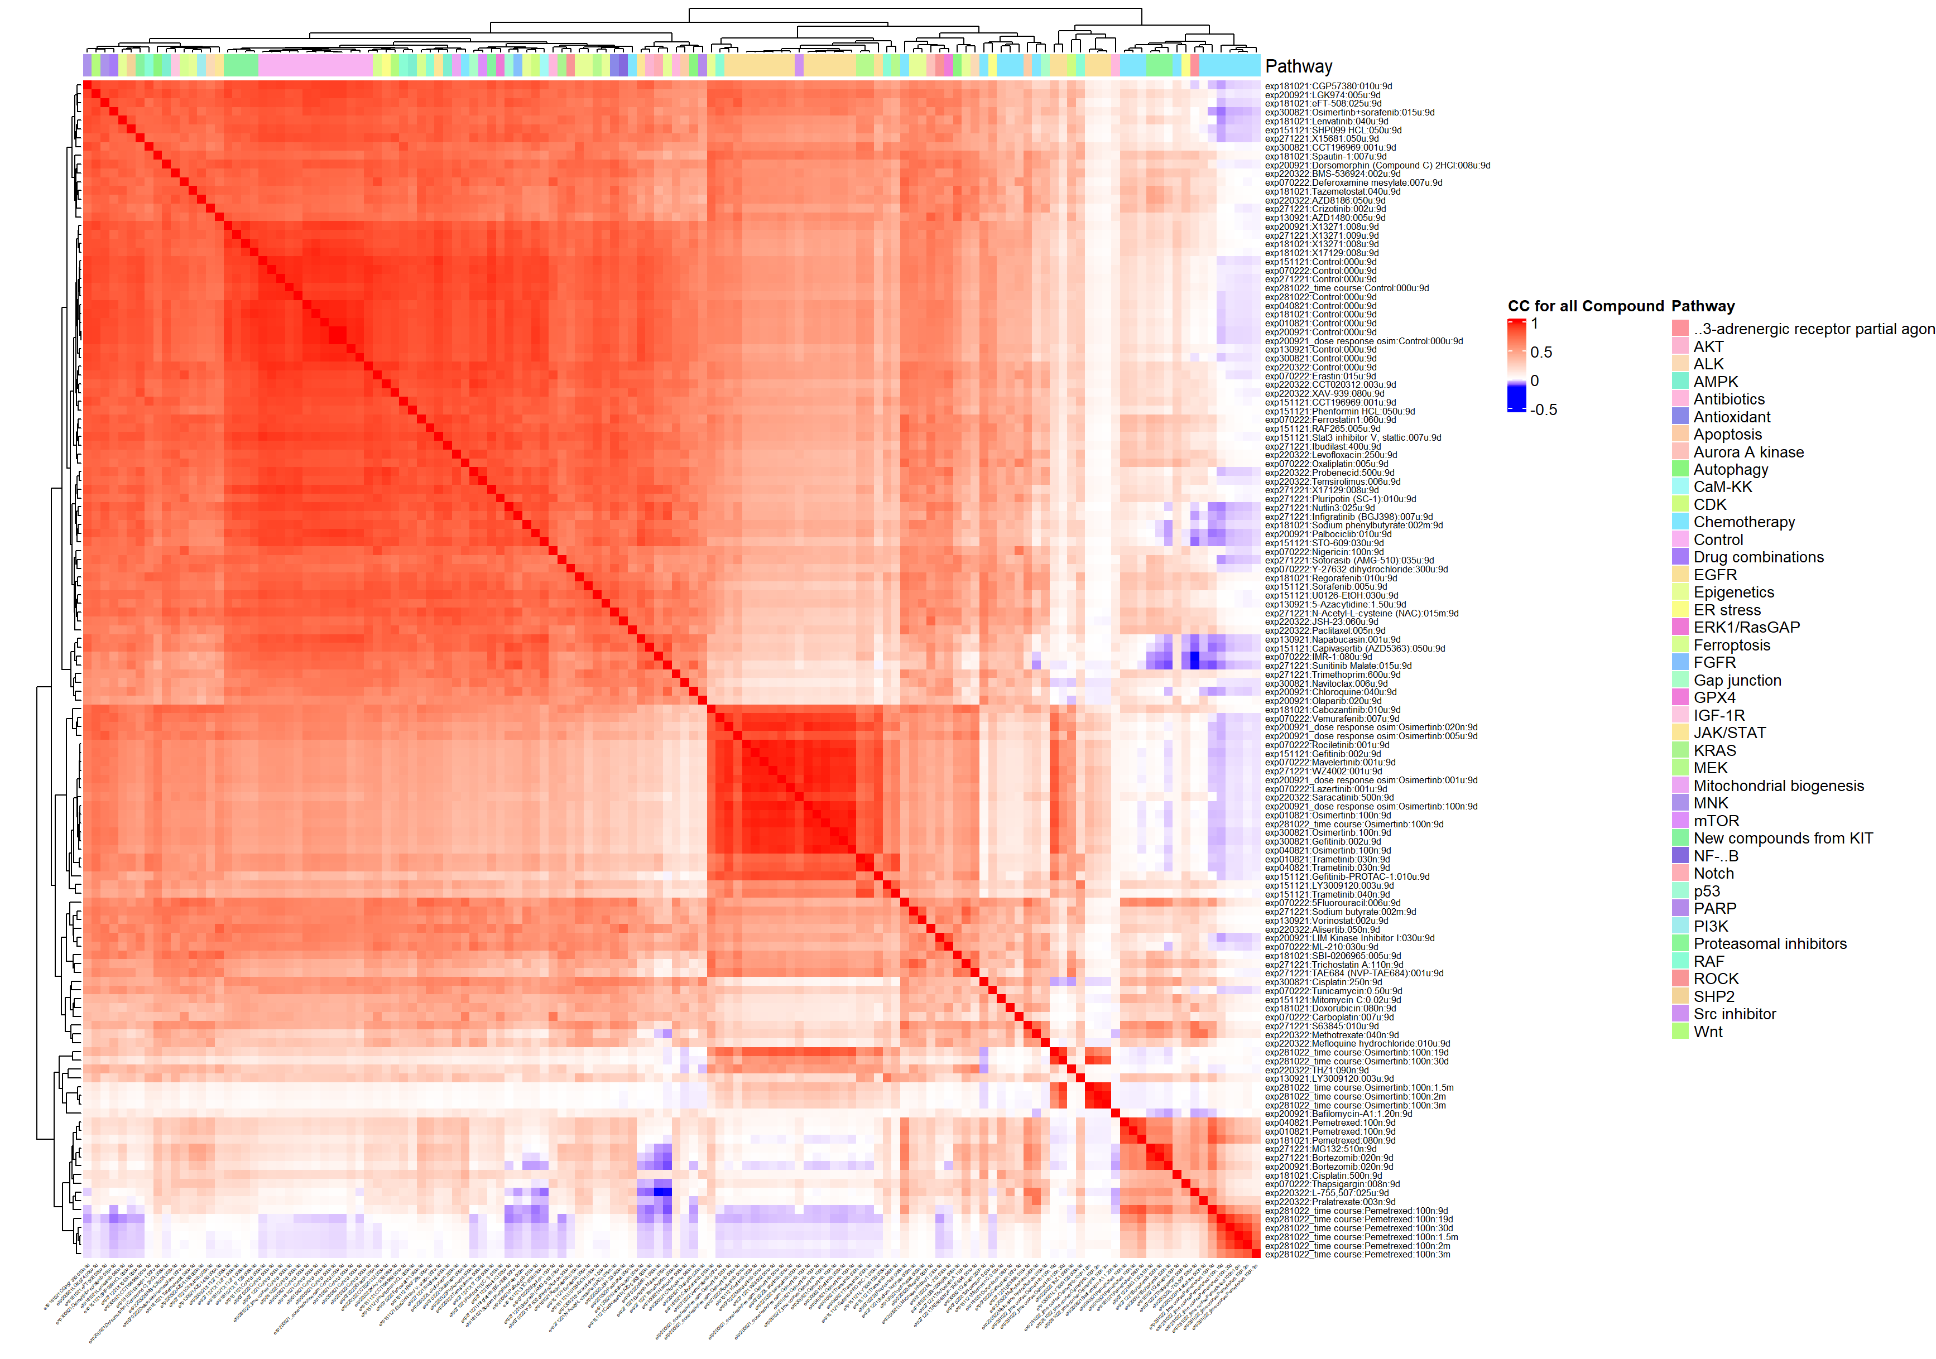
Figure 3.2: Heatmap of normalised compounds by batch(aggregated over replicates) with CC.
- Heatmap in Figure 3.3 is generated at the compound level:
## Read SummarizedExperiment object
se_normalised_compound <- readRDS(paste0("./results/compounds/se_normalised_per_compound_", today_date, ".rds"))
se_normalised_compound_mat <- SummarizedExperiment::assay(se_normalised_compound)
se_normalised_pheno_data_compound <- SummarizedExperiment::colData(se_normalised_compound)
## Compute global correlation score
cor_per_compound <- cor(se_normalised_compound_mat)
## Define clustering colours
col_heatmap_scale <- circlize::colorRamp2(c(min(cor_per_compound), 0, 1),
c("blue", "white", "red"))
## Heatmap annotation
ha <- ComplexHeatmap::HeatmapAnnotation(df = se_normalised_pheno_data_compound |>
as.data.frame() |>
dplyr::select(Pathway))
## Define Heatmap
heatmap_normalised_compound <- ComplexHeatmap::Heatmap(cor_per_compound,
col=col_heatmap_scale,
name = "CC for all Compound",
show_row_names = TRUE,
show_column_names = TRUE,
row_dend_reorder = FALSE,
column_dend_reorder = TRUE,
## font size
row_names_gp = gpar(fontsize = 6),
column_names_gp = gpar(fontsize = 6),
column_names_rot = 45,
top_annotation = ha,
## matrix size
width = ncol(cor_per_compound)*unit(3, "mm"),
height = nrow(cor_per_compound)*unit(3, "mm"))
size_heatmap <- calc_ht_size(heatmap_normalised_compound)
padding_heatmap <- unit(c(2, 15, 2, 2), "mm")
## 2) Save png and pdf outputs
png(paste0("figures/compounds/heatmap_normalised_compound_", today_date,".png"),
res = 300,
width = size_heatmap$width, height = size_heatmap$height, units = c("in"))
heatmap_normalised_compound |> ComplexHeatmap::draw(padding = padding_heatmap)
dev.off()
## png
## 2
knitr::include_graphics(paste0("figures/compounds/heatmap_normalised_compound_", today_date,".png"),
auto_pdf = TRUE,
dpi = 300)
ggsave(paste0("figures/compounds/heatmap_normalised_compound_", today_date,".pdf"),
heatmap_normalised_compound |>
ComplexHeatmap::draw(padding = padding_heatmap) |>
grid::grid.grabExpr(),
dpi = 300,
width = size_heatmap$width, height = size_heatmap$height, units = c("in"))
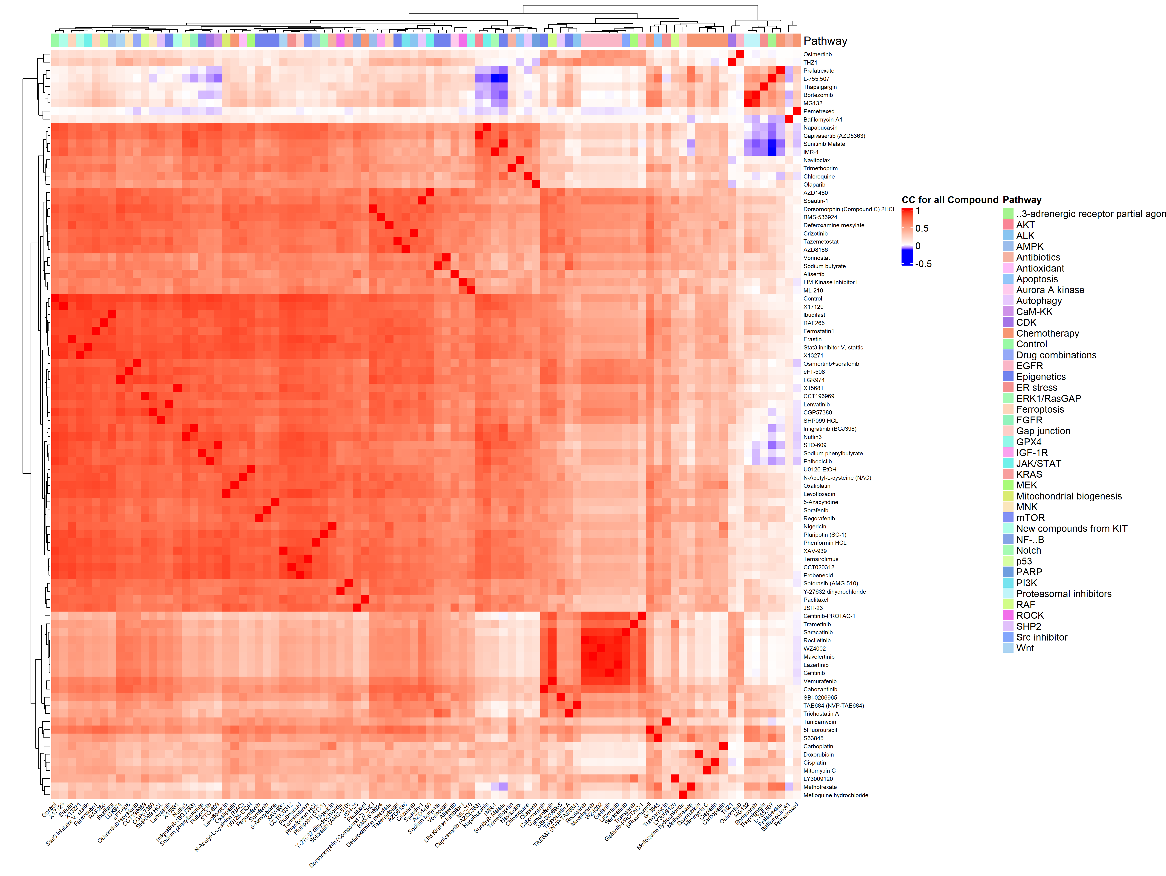
Figure 3.3: Heatmap generated with the simple Pearson Correlation score.

3.2.1.2 Heatmap with Pearson correlation and binarised values
- Heatmap at the replicates level in Figure 3.4:
## Read SummarizedExperiment object
se_binarised_replicates <- readRDS(paste0("./results/compounds/se_discretised_per_replicate_", today_date, ".rds"))
se_binarised_replicates_mat <- SummarizedExperiment::assay(se_binarised_replicates)
se_binarised_pheno_data_replicate <- SummarizedExperiment::colData(se_binarised_replicates)
## Compute global correlation score
cor_per_replicates <- cor(se_binarised_replicates_mat)
## Define clustering colours
col_heatmap_scale <- circlize::colorRamp2(c(min(cor_per_replicates), 0, 1),
c("blue", "white", "red"))
## Heatmap annotation
ha <- ComplexHeatmap::HeatmapAnnotation(df = se_binarised_pheno_data_replicate |>
as.data.frame() |>
dplyr::select(Pathway, Batch_ID, Compound))
heatmap_binarised_replicates <- ComplexHeatmap::Heatmap(cor_per_replicates,
col=col_heatmap_scale,
name = "CC at binarised Compound Level",
show_row_names = TRUE,
show_column_names = TRUE,
row_dend_reorder = FALSE,
column_dend_reorder = TRUE,
## font size
row_names_gp = gpar(fontsize = 2),
column_names_gp = gpar(fontsize = 2),
column_names_rot = 45,
top_annotation = ha,
## matrix size
width = ncol(cor_per_replicate)*unit(1, "mm"),
height = nrow(cor_per_replicate)*unit(1, "mm"))
size_heatmap <- calc_ht_size(heatmap_binarised_replicates)
padding_heatmap <- unit(c(2, 15, 2, 2), "mm")
## 2) Save png and pdf outputs
png(paste0("figures/compounds/heatmap_binarised_replicates_", today_date,".png"),
res = 100,
width = size_heatmap$width, height = size_heatmap$height, units = c("in"))
heatmap_binarised_replicates |> ComplexHeatmap::draw(padding = padding_heatmap)
dev.off()
## png
## 2
knitr::include_graphics(paste0("figures/compounds/heatmap_binarised_replicates_", today_date,".png"),
auto_pdf = TRUE,
dpi = 100)
ggsave(paste0("figures/compounds/heatmap_binarised_replicates_", today_date,".pdf"),
heatmap_binarised_replicates |>
ComplexHeatmap::draw(padding = padding_heatmap) |>
grid::grid.grabExpr(),
dpi = 100,
width = size_heatmap$width, height = size_heatmap$height, units = c("in"))
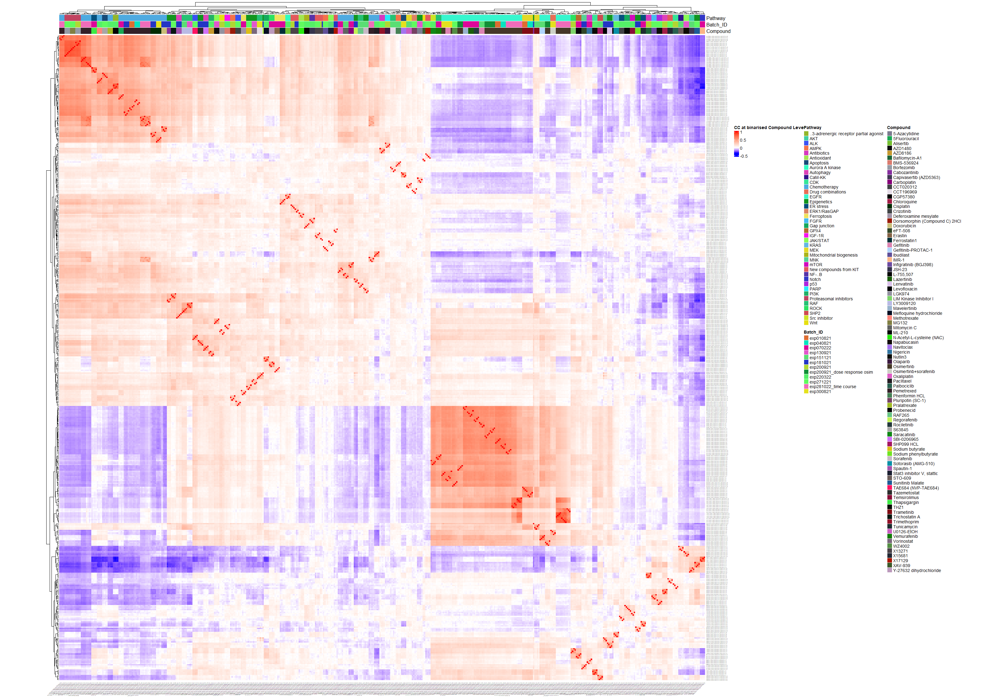
Figure 3.4: Heatmaps at the replicates level.
- Heatmap at the compound by batch level in Figure 3.5 (aggregated over technical replicates):
## Read SummarizedExperiment object
se_binarised_compound_batch <- readRDS(paste0("./results/compounds/se_discretised_per_compound_by_batch_", today_date, ".rds"))
se_binarised_compound_batch_mat <- SummarizedExperiment::assay(se_binarised_compound_batch)
se_binarised_pheno_data_compound_batch <- SummarizedExperiment::colData(se_binarised_compound_batch)
## Compute global correlation score
cor_per_compound_by_batch <- cor(se_binarised_compound_batch_mat)
## Define clustering colours
col_heatmap_scale <- circlize::colorRamp2(c(min(cor_per_compound_by_batch), 0, 1),
c("blue", "white", "red"))
## Heatmap annotation
ha <- ComplexHeatmap::HeatmapAnnotation(df = se_binarised_pheno_data_compound_batch |>
as.data.frame() |>
dplyr::select(Pathway, MoA))
heatmap_binarised_compound_batch <- ComplexHeatmap::Heatmap(cor_per_compound_by_batch,
col=col_heatmap_scale,
name = "CC at binarised Compound Level",
show_row_names = TRUE,
show_column_names = TRUE,
row_dend_reorder = FALSE,
column_dend_reorder = TRUE,
## font size
row_names_gp = gpar(fontsize = 6),
column_names_gp = gpar(fontsize = 3),
column_names_rot = 45,
top_annotation = ha,
## matrix size
width = ncol(cor_per_compound_by_batch)*unit(2, "mm"),
height = nrow(cor_per_compound_by_batch)*unit(2, "mm"))
size_heatmap <- calc_ht_size(heatmap_binarised_compound_batch)
padding_heatmap <- unit(c(2, 15, 2, 2), "mm")
## 2) Save png and pdf outputs
png(paste0("figures/compounds/heatmap_binarised_compound_by_batch_", today_date,".png"),
res = 200,
width = size_heatmap$width, height = size_heatmap$height, units = c("in"))
heatmap_binarised_compound_batch |> ComplexHeatmap::draw(padding = padding_heatmap)
dev.off()
## png
## 2
knitr::include_graphics(paste0("figures/compounds/heatmap_binarised_compound_by_batch_", today_date,".png"),
auto_pdf = TRUE,
dpi = 200)
ggsave(paste0("figures/compounds/heatmap_binarised_compound_by_batch_", today_date,".pdf"),
heatmap_binarised_compound_batch |>
ComplexHeatmap::draw(padding = padding_heatmap) |>
grid::grid.grabExpr(),
dpi = 200,
width = size_heatmap$width, height = size_heatmap$height, units = c("in"))
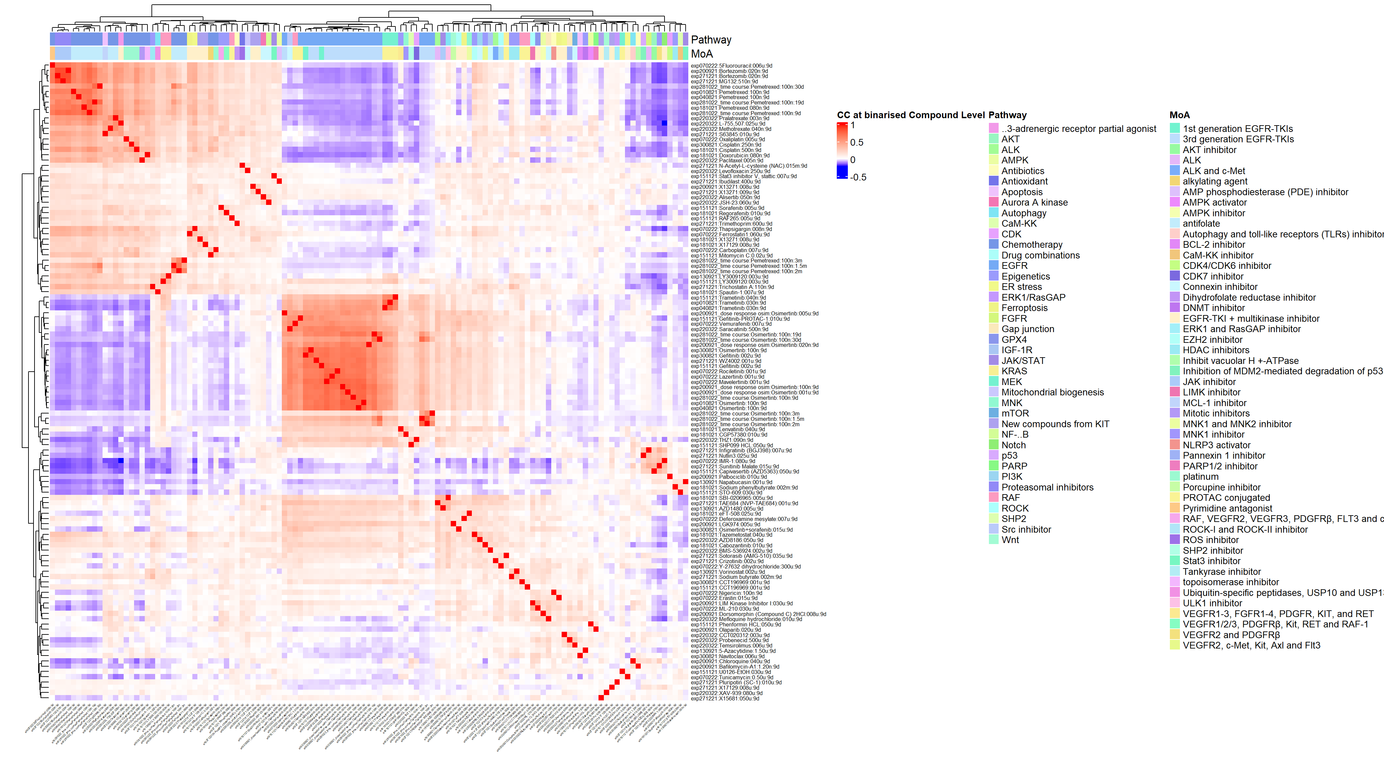
Figure 3.5: Heatmaps at the compound by batch level.
- Heatmap at the compound level in Figure 3.6.
## Read SummarizedExperiment object
se_binarised_compound <- readRDS(paste0("./results/compounds/se_discretised_per_compound_", today_date, ".rds"))
se_binarised_compound_mat <- SummarizedExperiment::assay(se_binarised_compound)
se_binarised_pheno_data_compound <- SummarizedExperiment::colData(se_binarised_compound)
## Compute global correlation score
cor_per_compound <- cor(se_binarised_compound_mat)
## Define clustering colours
col_heatmap_scale <- circlize::colorRamp2(c(min(cor_per_compound), 0, 1),
c("blue", "white", "red"))
## Heatmap annotation
ha <- ComplexHeatmap::HeatmapAnnotation(df = se_binarised_pheno_data_compound |>
as.data.frame() |>
dplyr::select(Pathway, MoA))
heatmap_binarised_compound <- ComplexHeatmap::Heatmap(cor_per_compound,
col=col_heatmap_scale,
name = "CC at binarised Compound Level",
show_row_names = TRUE,
show_column_names = TRUE,
row_dend_reorder = TRUE,
column_dend_reorder = TRUE,
row_names_gp = gpar(fontsize = 8),
column_names_gp = gpar(fontsize = 8),
column_names_rot = 45,
top_annotation = ha,
## matrix size
width = ncol(cor_per_compound)*unit(4, "mm"),
height = nrow(cor_per_compound)*unit(4, "mm"))
size_heatmap <- calc_ht_size(heatmap_binarised_compound)
padding_heatmap <- unit(c(2, 10, 2, 2), "mm")
## 2) Save png and pdf outputs
png(paste0("figures/compounds/heatmap_binarised_compound_", today_date,".png"),
res = 300,
width = size_heatmap$width, height = size_heatmap$height, units = c("in"))
heatmap_binarised_compound |> ComplexHeatmap::draw(padding = padding_heatmap)
dev.off()
## png
## 2
knitr::include_graphics(paste0("figures/compounds/heatmap_binarised_compound_", today_date,".png"),
auto_pdf = TRUE,
dpi = 300)
ggsave(paste0("figures/compounds/heatmap_binarised_compound_", today_date,".pdf"),
heatmap_binarised_compound |>
ComplexHeatmap::draw(padding = padding_heatmap) |>
grid::grid.grabExpr(),
dpi = 300,
width = size_heatmap$width, height = size_heatmap$height, units = c("in"))
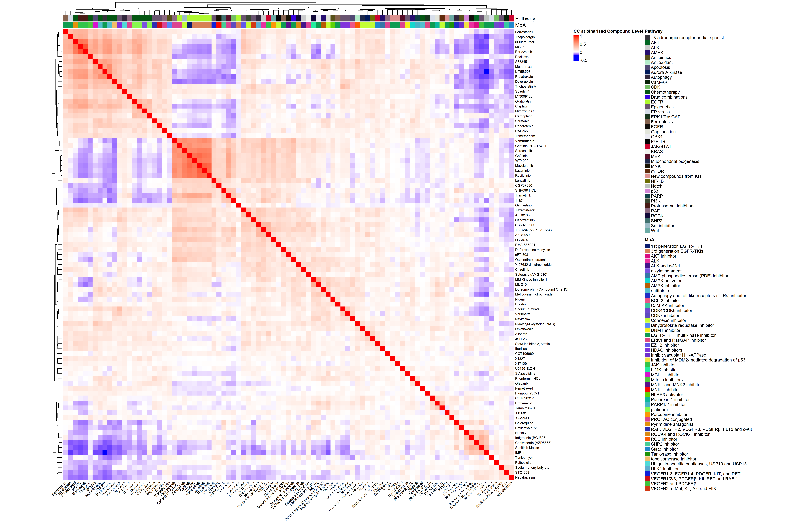
Figure 3.6: Heamaps at the compound level.

3.2.2 Compound Networks
- Plot weighted undirected compound graphs with igraph::graph_from_adjacency_matrix in Figure 3.7, filtering out pairwise connections between 2 drugs if the $p$-value is not significant and absolute correlation score is below 0.8:
#| label: fig-igraph-drug
## 1) Compute correlation matrix and p-values ----
cor_res <- Hmisc::rcorr(se_binarised_compound_mat, type = "pearson")
cor_binarised_compound <- cor_res$r
pval_binarised_compound <- cor_res$P
adj_mat <- cor_binarised_compound
adj_mat[pval_binarised_compound > 0.05/ncol(cor_res)] <- 0
## 2) build igraph adjacency matrix ----
compound_graph <- igraph::graph_from_adjacency_matrix(adjmatrix=adj_mat,
weighted = TRUE,
diag = FALSE,
mode = "undirected")
## 3) igraph customisation ----
compound_graph$date <- today_date
E(compound_graph)$color <- if_else(E(compound_graph)$weight >0, "red", "blue")
E(compound_graph)$weight <- abs(E(compound_graph)$weight)
layout_graph <- igraph::layout_with_fr(compound_graph,
niter = 500)
# graph dimension sizes
graph_width <- range(layout_graph[,1]) |> diff()
graph_height <- range(layout_graph[,2]) |> diff()
aspect_ratio <- graph_width / graph_height
vertex_structure <- se_binarised_pheno_data_compound |>
as.data.frame() |>
dplyr::mutate(color = if_else(Pathway=="EGFR", "green", "yellow"))
igraph::V(compound_graph)$color <- vertex_structure$color
pdf(paste0("figures/compounds/compound_graph_", today_date, ".pdf"),
width = 14 * aspect_ratio, height = 14,
useDingbats = TRUE, compress = FALSE)
plot(compound_graph, layout = layout_graph, vertex.size = 10,
## vertex.label.dist= 2,
main = "Compound network interaction.
In green, drugs related with the EGFR mechanism,
and in yellow other pathways.
Edge widths are proportional to the coefficient of correlation.",
edge.width = igraph::E(compound_graph)$weight * 20,
vertex.label.cex = 0.9, curved = 0.2)
dev.off()
## png
## 2
## 4) export PNG and readable graph formats for Neo4J
png(paste0("figures/compounds/compound_graph_", today_date, ".png"),
width = 14 * aspect_ratio, height = 14,
res = 200, units = c("in"))
plot(compound_graph, layout = layout_graph, vertex.size = 10,
## vertex.label.dist= 2,
main = "Compound network interaction.
In green, drugs related with the EGFR mechanism,
and in yellow other pathways.
Edge widths are proportional to the coefficient of correlation.",
edge.width = igraph::E(compound_graph)$weight * 20,
vertex.label.cex = 0.9, curved = 0.2)
dev.off()
## png
## 2
knitr::include_graphics(paste0("figures/compounds/compound_graph_", today_date, ".png"),
dpi = 200, auto_pdf = TRUE)
igraph::write_graph(graph = compound_graph,
file = paste0("./results/compounds/compound_network_", today_date, ".graphml"),
format = "graphml")
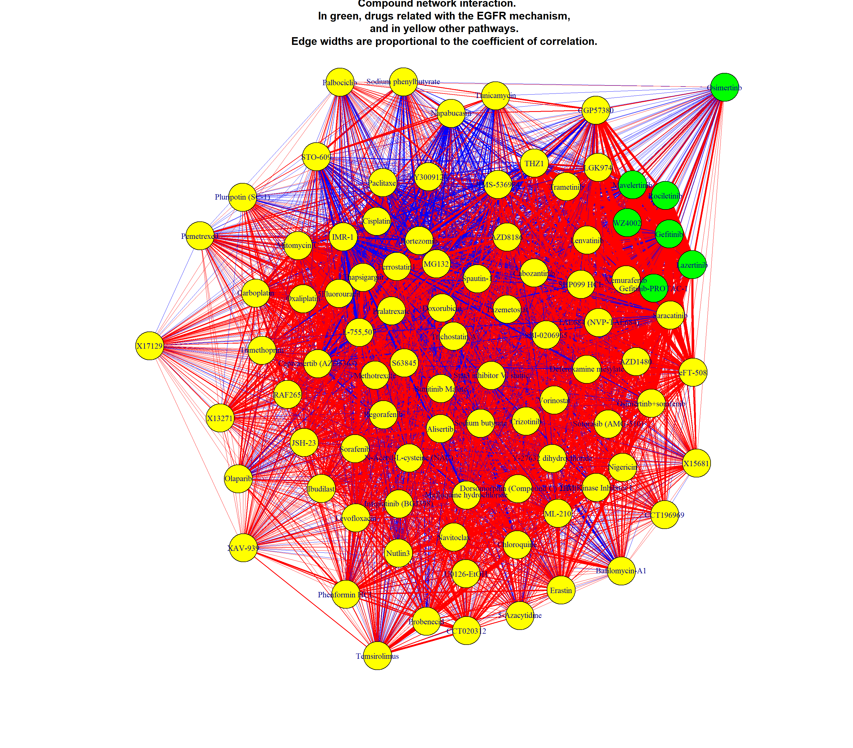
Figure 3.7: Drug-drug network interactions, at the compound level.

3.3 Compute Cell Lines Similarities

3.3.1 Cell Line by Compound
se_binarised_compound_batch_fac <- apply(se_binarised_compound_batch_mat, 2, as.character)
## Heatmap annotation
ha <- ComplexHeatmap::HeatmapAnnotation(df = se_binarised_pheno_data_compound_batch |>
as.data.frame() |>
dplyr::select(Batch_ID, Pathway, Compound))
heatmap_cell_lines_by_sample <- ComplexHeatmap::Heatmap(se_binarised_compound_batch_fac,
col = c("TRUE" = "red", "FALSE" = "blue"),
name = "Heatmap: cell-line by sample",
show_row_names = FALSE,
row_dend_reorder = TRUE,
## clustering_distance_rows = "pearson",
show_row_dend = FALSE,
column_dend_reorder = TRUE,
show_column_names = TRUE,
column_names_gp = gpar(fontsize = 6),
column_names_rot = 45,
top_annotation = ha,
## matrix size
width = ncol(se_binarised_compound_batch_fac)*unit(3, "mm"),
height = nrow(se_binarised_compound_batch_fac)*unit(0.3, "mm"),
use_raster = TRUE)
size_heatmap <- calc_ht_size(heatmap_cell_lines_by_sample)
padding_heatmap <- unit(c(2, 10, 2, 2), "mm")
## 2) Save png and pdf outputs
png(paste0("figures/cell_lines/heatmap_cell_lines_by_samples_", today_date,".png"),
res = 50,
width = size_heatmap$width, height = size_heatmap$height, units = c("in"))
heatmap_cell_lines_by_sample |> ComplexHeatmap::draw(padding = padding_heatmap)
dev.off()
## png
## 2
knitr::include_graphics(paste0("figures/cell_lines/heatmap_cell_lines_by_samples_", today_date,".png"),
auto_pdf = TRUE,
dpi = 50)
ggsave(paste0("figures/cell_lines/heatmap_cell_lines_by_samples_", today_date,".pdf"),
heatmap_cell_lines_by_sample |>
ComplexHeatmap::draw(padding = padding_heatmap) |>
grid::grid.grabExpr(),
dpi = 200, limitsize = FALSE,
width = size_heatmap$width, height = size_heatmap$height, units = c("in"))
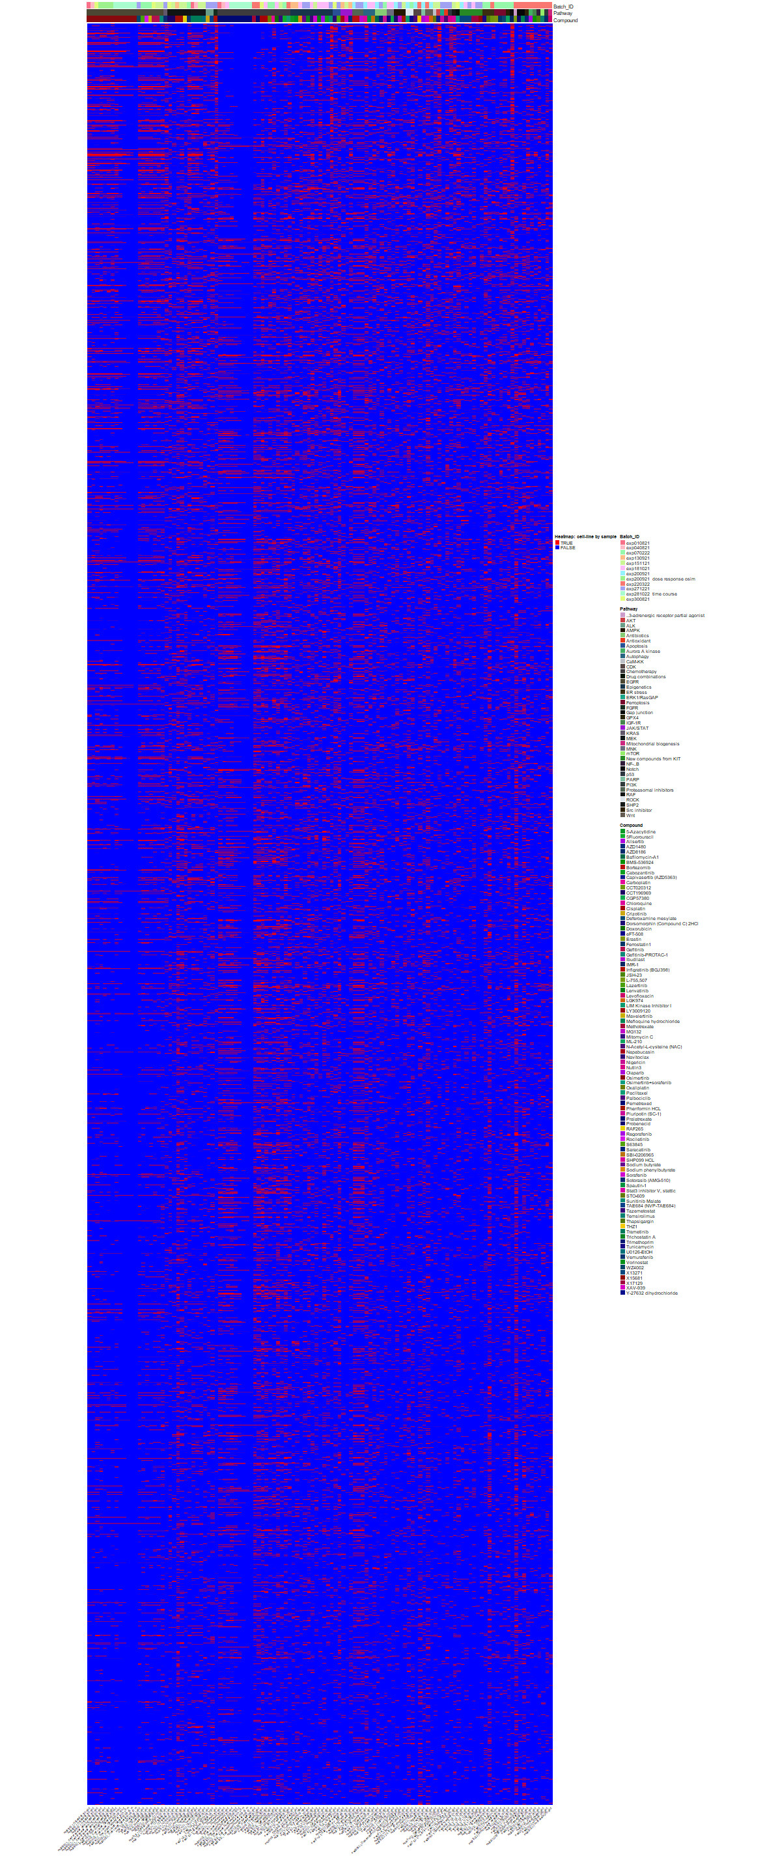
Figure 3.8: Heatmap cell lines by samples, averaging over replicates.

4. Future perspectives: single-cell integration.

4.0.1 Alternative metrics
- Compute correlations with strongly sparse vectors?

4.0.2 Pair Single Cell with (or without) Drug fingerprints
- Single cell and compound response largest database
- Biologist perspective
  - Single-cell lineage capture across genomic modalities with CellTag-multi reveals fate-specific gene regulatory changes -> use of single-cell lineage-tracing (scLT).
  - High-resolution, noninvasive single-cell lineage tracing in mice and humans based on DNA methylation epi-mutations.
- Ming Tommy Tang lists in Single-cell LinkedIn post trendy papers and tools for multi-sample, single-cell RNAseq differential expression analysis.

4.0.2.1 Correct for Batch Effects
- DESeq2-MultiBatch: Batch Correction for Multi-Factorial RNA-seq Experiments, avalaible as open-source GH repository, from Roy, Monthony, and Torkamaneh (2025).

4.0.2.2 Drug-response
- TRADE: Transcriptome-wide analysis of differential expression in perturbation atlases, from Nadig et al. (2025). The paper notably reports how to model a compound-dose response curve with a Hill equation. Avalaible as an open-source GH repository TRADEtools. R TRADE Tutorial

4.0.3 Barcode Differential Analysis

4.0.3.1 bartools and BARtab
- Analysis of synthetic cellular barcodes in the genome and transcriptome with BARtab and bartools.

4.0.3.2 DEBRA
- Pros DEBRA
  - Better characterisation of the mean-variance deviation -> between trended or shrinkage, trended is favoured.
- Cons DEBRA:
  - DEBRA does not account for outliers expression, nor zero-inflated counts -> recommendation of glmQLFit and glmQLFTest for routine GLM-based DE analyses, from EdgeR: Explaning dispersion types to newbies.
  - Complex protocol for discarding lowly differentially expressed barcodes.
  - No available BioConductor/CRAN Repository, while latest DEBRA GitHub update dates back more than 4 years.

4.0.3.3 Combine Fold change and $p$-value
- Combine statistical discernibility (aka significance) with practical significance

4.0.4 Drug clustering and mapping
- Use of graph clustering approaches? Like Louvain? + multiple case studies, how to combine them (2 vials of cell lines)?
- Compare with ATC prediction and clustering: PDATC-NCPMKL-updated GH Repo.

Appendix A — Appendix: publish to standardised cell line repositories.

A.1 Repository organisation and Data tracking
- Project Code Organisation
- Data Fingerprinting with MDA5 and Environment Snapshots: R and Code tracking
- Large datasets versioning:
  - DataLad VS DVC
  - DataLad Versus DVC, and DataLad Versus DVC V2
  - Git LFS VS Alembic
- Homogenise Excel colnames, and other spreadsheet tips

A.2 Publish cell lines on Web repositories
- cellosaurus General Comments and cellosaurus Official Website, from(Bairoch 2018; Robin, Capes-Davis, and Bairoch 2020). Specifically, the CLASTR algorithm relies on short-tandem repeat patterns to map user-provided cell lines with the ones available in Cellosaurus database.
- Bgee.

Bibliographic References
Bairoch, Amos. 2018. ‘The Cellosaurus, a Cell-Line Knowledge Resource’. Journal of Biomolecular Techniques : JBT 29 (2): 25–38. https://doi.org/10.7171/jbt.18-2902-002.
Gehlenborg, Nils, and Bang Wong. 2012. ‘Mapping Quantitative Data to Color’. Nature Methods 9 (8): 769–69. https://doi.org/10.1038/nmeth.2134.
Nadig, Ajay, Joseph M. Replogle, Angela N. Pogson, Mukundh Murthy, Steven A. McCarroll, Jonathan S. Weissman, Elise B. Robinson, and Luke J. O’Connor. 2025. ‘Transcriptome-Wide Analysis of Differential Expression in Perturbation Atlases’. Nature Genetics, April, 1–10. https://doi.org/10.1038/s41588-025-02169-3.
Robin, Thibault, Amanda Capes-Davis, and Amos Bairoch. 2020. ‘CLASTR: The Cellosaurus STR Similarity Search Tool - A Precious Help for Cell Line Authentication’. International Journal of Cancer 146 (5): 1299–1306. https://doi.org/10.1002/ijc.32639.
Roy, Julien, Adrian S. Monthony, and Davoud Torkamaneh. 2025. ‘DESeq2-MultiBatch: Batch Correction for Multi-Factorial RNA-seq Experiments’. 22 April 2025. https://doi.org/10.1101/2025.04.20.649392.

Test the Helmert contrast to evaluate compound dose response, or time-course replicates. Also For repeated measures across time, see One Way repeated measure ANOVA in R

